**台州学院**

**电子与信息工程学院课后作业**

班级 24计算机 学号 2462710034L 姓名 仙女

作业日期： 2024 年 4 月 16 日

Chapter10 Thinking in Objects

**Project: Calculate BMI**

Problem Description:

1. Create a java class to calculate the BMI
2. The class should have data field: name age weight height
3. The class should have methods: getBMI getStatus
4. Write a Test class to test the BMI class

Analysis:

In this study case we need to create a program to calculate the BMI (Body Mass Index) based on the the weight and the height. Prompt the user to input their name, age, weight, and height. Create a class to define the variables and methods to calculate the BMI with a formula of dividing the weight with squared of height. Then check the condition whether the data from user is underweight, normal, overweight, or obese if the condition meets.

Design:

(Describe the major steps for solving the problem. Draw the UML class diagram for BMI)

Create a class calculateBMI contain all of the data field, constructor, and method such as name, age, weight, and height for the data fields, CalculateBMI() for the constructor, and getBMI() and getStatus() for the methods. Calculate the BMI within getBMI() method with *weight / (height * height)* as a return. As for the getStatus() method is used to check whether the data from the user is considered as underweight, normal, overweight, or obese. Demonstrate the calculation in a new class TestCalculateBMI, first prompt the user to input name, age, weight, and height. Create a new object namely person to recall the methods from CalculateBMI class. Print the statements of input data from user as it will be shown in the result.

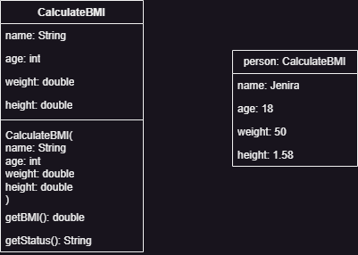

Coding:

public class CalculateBMI {  
 String name;  
 int age;  
 double weight;  
 double height;  
  
 CalculateBMI(String *name*, int *age*, double *weight*, double *height*) {  
 this.name = *name*;  
 this.age = *age*;  
 this.weight = *weight*;  
 this.height = *height*;  
 }  
  
 double getBMI() {  
 return weight / (height * height);  
 }  
  
 String getStatus() {  
 double bmi = getBMI();  
  
 if (bmi < 18.5) {  
 return "Underweight";  
 } else if (bmi < 25.0) {  
 return "Normal";  
 } else if (bmi < 30.0) {  
 return "Overweight";  
 } else {  
 return "Obese";  
 }  
 }  
}

import java.util.Scanner;  
  
public class TestCalculateBMI {  
 public static void main(String[] *args*) {  
 Scanner input = new Scanner(System.in);  
  
 System.out.print("Enter your name: ");  
 String name = input.nextLine();  
  
 System.out.print("Enter your age: ");  
 int age = input.nextInt();  
  
 System.out.print("Enter your weight in kg: ");  
 double weight = input.nextDouble();  
  
 System.out.print("Enter your height in meters: ");  
 double height = input.nextDouble();  
  
 CalculateBMI person = new CalculateBMI(name, age, weight, height);  
  
 System.out.println("\nBMI results for " + name + ":");  
 System.out.println("BMI: " + String.**format**("%.2f", person.getBMI()));  
 System.out.println("Status: " + person.getStatus());  
 }  
}

Testing: (Describe how you test this program)

Test 1

Run the program, enter the requested data for name is “Jenira”, age is “18”, weight is “50.0”, and height is “1.58”, the program will execute and show the result of person Jenira is Normal.